SIMATS ENGINEERING

ASSESSMENT TOOL 2

COURSE NAME: INTERNET PROGRAMMING COURSE CODE: CSA4305

COURSE OUTCOME COVERED

CO -2 : Apply CSS layout and styling techniques to create visually appealing and responsive web interfaces, and use JavaScript to enable interactive client-side behavior. (L3)

Assessment Tool : Design Task

Weightage: 20%

QUESTIONS: Total Marks: 20

Question 1: Responsive Navigation Bar Design - Marks(4)
Suppose that an e-commerce website requires a responsive navigation bar that adapts across desktop, tablet, and mobile devices.
- Identify key components required in a navigation bar for an e-commerce website.
- Design a responsive navigation bar using appropriate CSS techniques.
- Demonstrate how the navigation adapts to smaller screens (e.g., hamburger menu).
- Evaluate the usability and suggest improvements for better user experience.

Question 2: Product Hover Effect - Marks(4)
Suppose that an e-commerce website wants to enhance user interaction through visual effects on product items.
- Identify suitable CSS properties for hover effects.
- Suggest appropriate CSS animation or transition for product interaction.
- Design a hover effect for a product card.
- Evaluate performance and user experience considerations.

Question 3: Layout Selection (Flexbox vs Grid) - Marks(4)
Suppose that a dashboard layout needs to be designed for a web application.
- Identify layout requirements of a dashboard (rows, columns, alignment).

- Compare Flexbox and Grid based on layout needs.
- Choose the most suitable layout technique and justify your choice.
- Evaluate the scalability and responsiveness of the chosen approach.

Question 4: Mobile-First Blog Layout - Marks(4)
Suppose that a blog page must be designed following a mobile-first approach.
- Identify key sections of a blog layout.
- Design a mobile-first layout using CSS.
- Demonstrate how the layout scales for larger screens using media queries.
- Evaluate accessibility and readability of the design.

Question 5: JavaScript Event Handling for Dynamic Menu - Marks(4)
Suppose that a website includes a dynamic menu that responds to user interactions.
- Identify appropriate JavaScript events for menu interaction.
- Design event handling logic for menu toggle functionality.
- Implement interaction for user actions (click/hover).
- Evaluate performance and suggest improvements.

Code of Conduct:

I (g.pradeep ranga reddy/ 1923112) certify that this submission is my original work and that I have adhered to the guidelines specified for this assessment. I understand that any violation of academic integrity rules will result in disciplinary action.

Signature of the student:
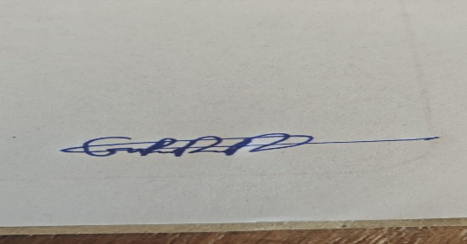

RUBRICS FOR CALCULATION:

Criteria | Weightage (%) | Level 4 –  Exemplary (4) | Level 3 –  Proficient (3) | Level 2 –  Developing (2) | Level 1 –  Beginning (1)
Understanding of Concept | 25 | Demonstrates complete understanding of design requirements and concepts | Good understanding with minor gaps | Basic understanding with some errors | Poor understanding or incorrect concepts
Design / Implementation | 30 | Well-structured, efficient, and responsive design implementation | Correct implementation with minor issues | Basic implementation with inconsistencies | Incorrect or incomplete implementation
Use of Tools (CSS/JS) | 20 | Effective and advanced use of tools/techniques | Appropriate use of tools | Limited or inconsistent use | Incorrect or minimal use
Analysis & Evaluation | 15 | Insightful analysis with strong justification and optimization | Good analysis with justification | Basic analysis with limited depth | Poor or no analysis
Documentation / Clarity | 10 | Clear,  well-structure d, and properly  presented solution | Mostly clear with minor issues | Basic clarity, missing details | Poor or unclear documentation

Question 1: Responsive Navigation Bar Design (4 Marks)

Identify Key Components
A responsive navigation bar for an e-commerce website should include:

    - Website Logo
    - Home
    - Products/Categories
    - Search Bar
    - Shopping Cart
    - Login/Register
    - Contact Us
    - Hamburger Menu for mobile devices

Design
Use CSS Flexbox to align navigation items horizontally and media queries to make the layout responsive.

Sample HTML
<nav class="navbar">
<h2>ShopEasy</h2>

<div class="menu">
<a href="#">Home</a>
<a href="#">Products</a>
<a href="#">Cart</a>
<a href="#">Contact</a>
</div>
</nav>

Sample CSS
.navbar{ display:flex;
justify-content:space-between; align-items:center; background:#333; padding:15px;
}

.menu{ display:flex; gap:20px;
}

Demonstration
@media(max-width:768px){

.menu{ display:none;
flex-direction:column;
}

.menu.show{ display:flex;
}
}

Result:
- Desktop → Horizontal navigation
- Tablet → Flexible navigation
- Mobile → Hamburger menu

Evaluation

Advantages

    - Mobile-friendly
    - Easy navigation
    - Better user experience
    - Responsive across all devices

Suggested Improvements

    - Animated menu
    - Sticky navigation
    - Search suggestions
    - Dark mode

Output:

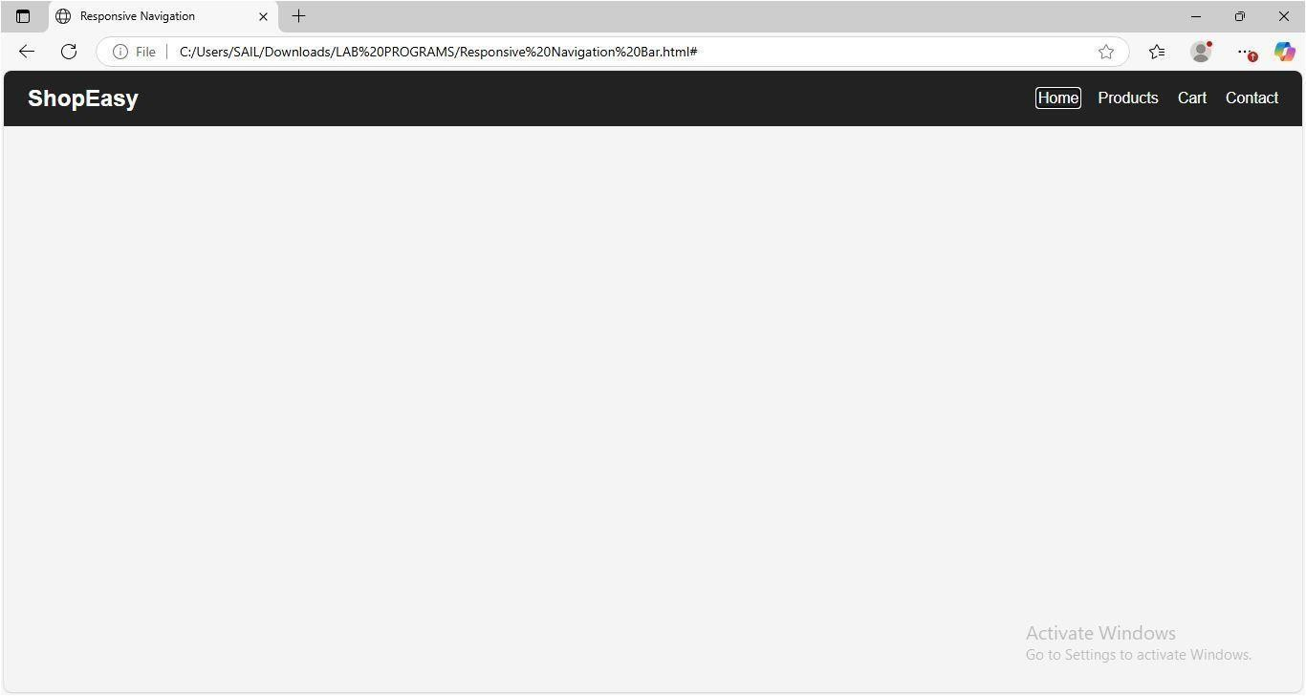

Question 2: Product Hover Effect (4 Marks)

CSS Properties
Suitable properties include:

  - transform
  - transition
  - box-shadow
  - opacity
  - border-radius
  - background-color

Animation
Use CSS Transition with Scale Effect.

transition:0.3s; transform:scale(1.05);

Design
.card{ width:220px; padding:20px;
box-shadow:0 0 10px gray; transition:0.4s;
}

.card:hover{ transform:scale(1.05);
box-shadow:0 0 20px black;

}

Evaluation
Advantages

  - Better product visibility
  - Interactive interface
  - Attractive appearance

Improvements

  - Use subtle animations
  - Optimize for low-end devices
  - Avoid excessive visual effects

Output:
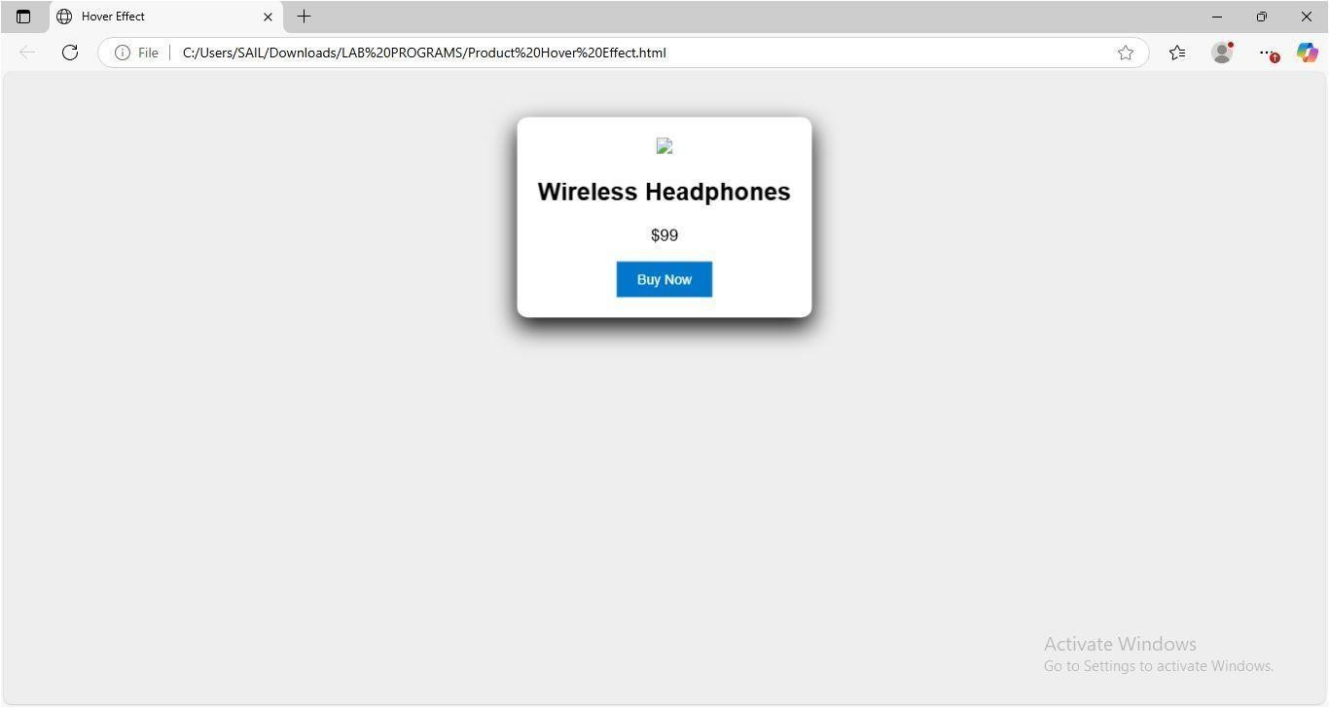

Question 3: Layout Selection (Flexbox vs Grid)

Dashboard Requirements
A dashboard generally contains:

  - Header
  - Sidebar
  - Main Content
  - Cards
  - Footer

It requires:
  - Rows
  - Columns
  - Proper alignment
  - Equal spacing

Comparison

Flexbox | Grid
One-dimensional | Two-dimensional
Best for rows or columns | Best for complete page layouts
Easier alignment | Better control over layout
Suitable for navigation | Suitable for dashboards

- Selecti on CSS Grid Reason:
  - Supports both rows and columns
  - Better dashboard organization
  - Easier responsive design

Evaluation
Advantages

  - Scalable
  - Responsive
  - Easy maintenance
  - Cleaner code

Output:
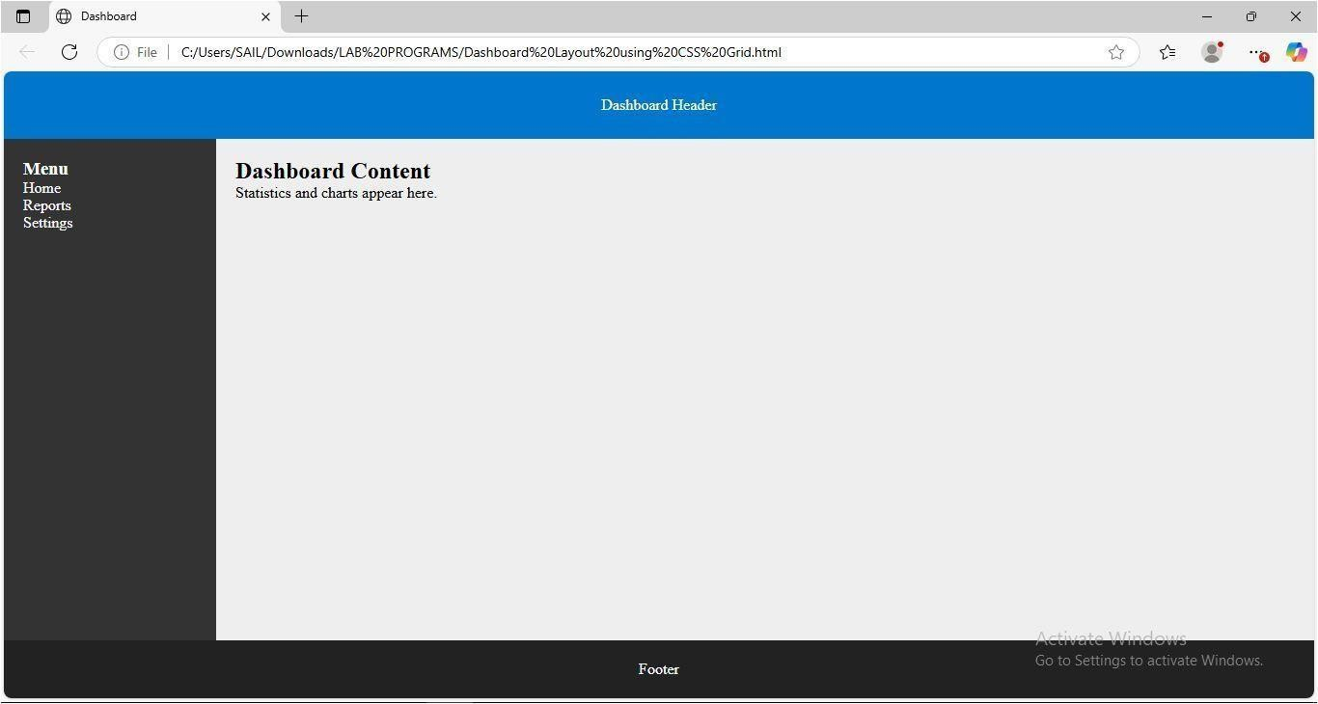

Question 4: Mobile-First Blog Layout

Key Sections
  - Header
  - Navigation
  - Blog Content
  - Sidebar
  - Footer

Design
.container{ display:flex;
flex-direction:column;

}

Mobile devices display a single-column layout.

Media Query
@media(min-width:768px){

.container{

flex-direction:row;

}

}

Desktop displays two columns.

Evaluation
Advantages

  - Better readability
  - Mobile-friendly
  - Faster loading
  - Accessible

Improvements

  - Dark mode
  - Larger fonts
  - Better spacing
  - Responsive images

Output:
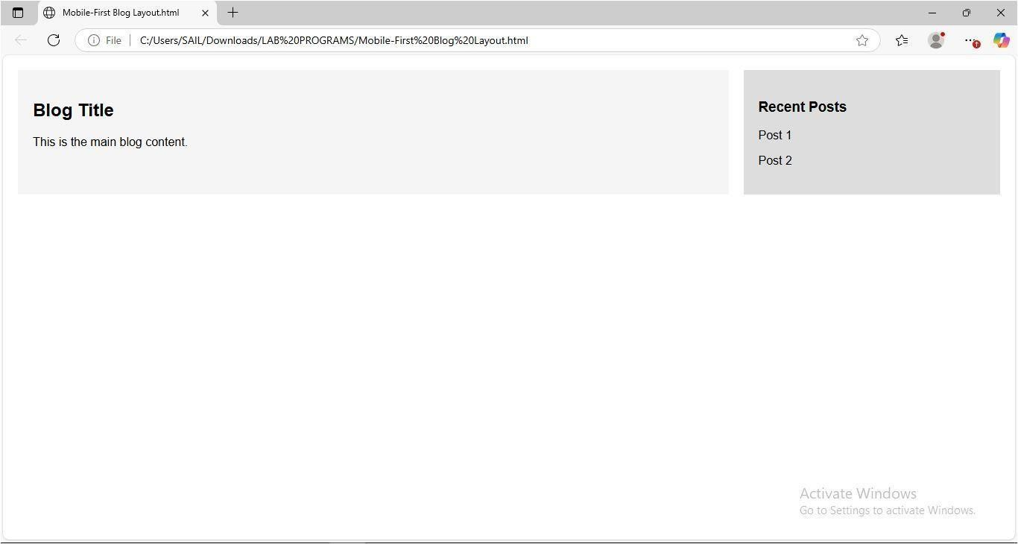

Question 5: JavaScript Event Handling

Events
Suitable events include:

  - click
  - mouseover
  - mouseout
  - keydown

Event Logic
Algorithm:

- User clicks menu icon.
- JavaScript checks menu status.
- If hidden, display menu.
- Otherwise, hide menu.

Implementation
function toggleMenu(){

let menu=document.getElementById("menu"); menu.classList.toggle("show");
}

Evaluation
Advantages

  - Fast response
  - Easy implementation
  - Improved navigation
  - Better mobile usability

Suggested Improvements
  - Keyboard accessibility
  - Smooth animations

  - ARIA labels
  - Touch gesture support

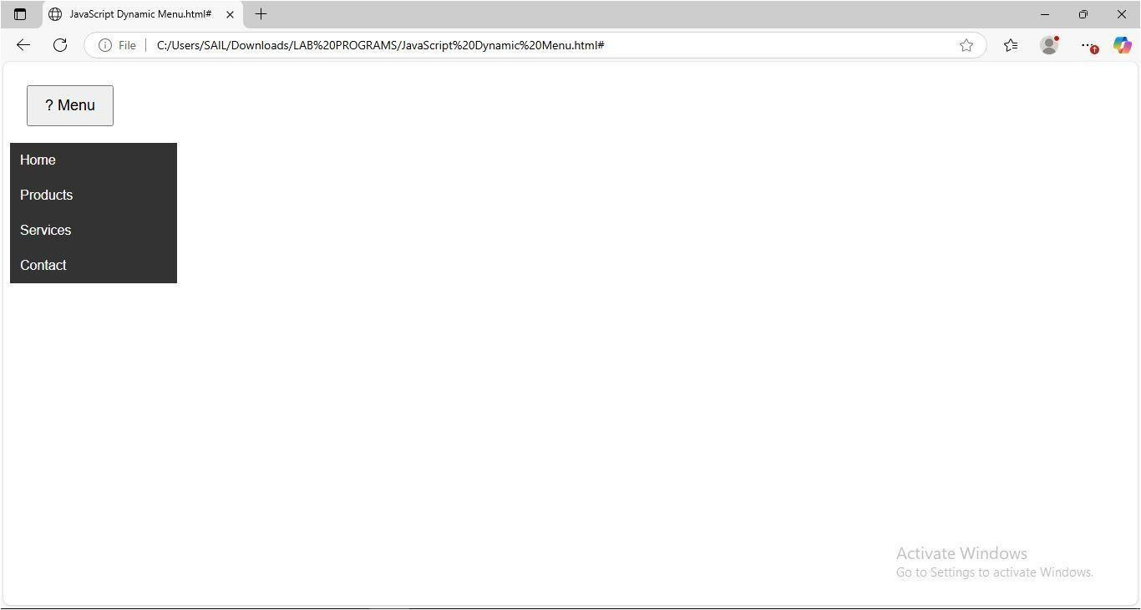
Output:

